Web Page On TRIFTING





I have made my website on thrifting because its Trending all over the world. The internet has played a critical role in the rise of thrifting. The pressure to stay trendy is inevitable in a market where mainstream brands like [Zara and H&M ship out new styles to stores biweekly, weekly, or even daily](https://books.google.com/books/about/Overdressed.html?id=yYzzFyBQ72oC).

Link for my website –

https://sites.google.com/view/thriffting/home

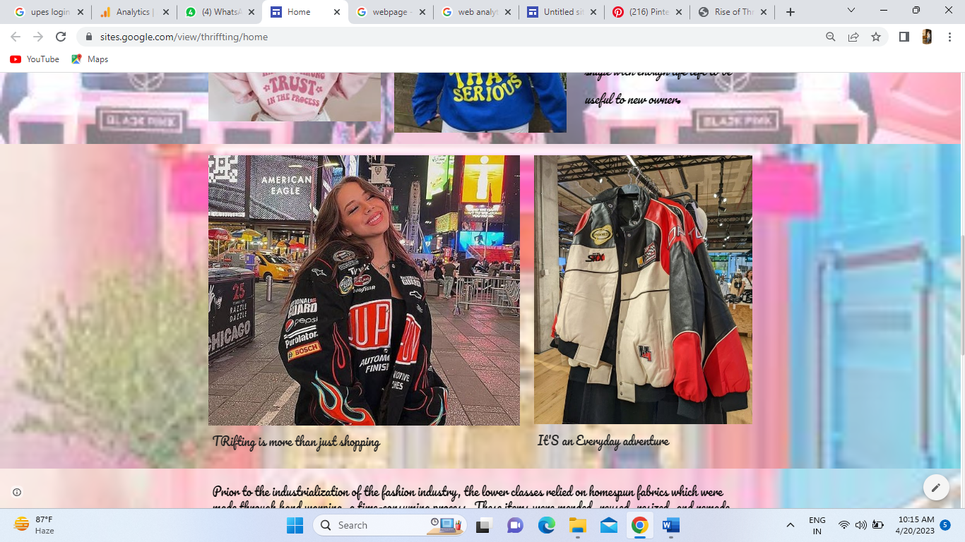



This web page on thrifting tells you:

1. What thrifting is: The page might define what thrifting is, and describe the concept of buying secondhand items instead of buying new.2. The benefits of thrifting: The page might discuss the benefits of thrifting, such as saving money, reducing waste, and finding unique items.

2. How to thrift: The page might provide tips and advice on how to thrift effectively, such as where to look for secondhand items, how to evaluate the quality of items, and how to negotiate prices.

3. Popular thrift stores: The page might recommend popular thrift stores or provide a directory of thrift stores in different locations.

4. Fashion and style tips: The page might offer fashion and style tips for incorporating thrifted items into your wardrobe, such as how to mix and match different pieces, how to style vintage items, and how to create a cohesive look.

5. Upcycling and DIY projects: The page might provide ideas and tutorials for upcycling thrifted items, such as how to transform a vintage dress into a modern skirt, or how to turn old t-shirts into a new piece of clothing.

6. Sustainability and environmental impact: The page might discuss the environmental benefits of thrift shopping, such as reducing the amount of clothing in landfills and decreasing the amount of resources needed to produce new clothing.

7. Ethical considerations: The page might explore the ethical considerations of thrifting, such as supporting local communities and reducing the demand for fast fashion.

8. Finding treasures: The page might provide tips for finding unique and valuable items while thrifting, such as looking for vintage or designer pieces, and exploring different sections of the thrift store

19. Cleaning and care: The page might offer advice on how to clean and care for thrifted items, such as how to wash delicate fabrics or remove stains from clothing.

10. Community and culture: The page might discuss the community and culture of thrifting, such as the social aspect of shopping with friends, or the sense of nostalgia and history that comes with vintage items.

Google Analytics

Google Analytics is a web analytics service offered by Google that tracks and reports website traffic. It allows website owners to monitor the performance of their website and gain insights into user behavior. The service provides a wide range of data, including the number of visitors to a website, their geographic location, the pages they visit, how long they stay on each page, and the devices they use to access the site.

Google Analytics works by placing a JavaScript tracking code on each page of a website. This code collects data on user behavior and sends it back to Google's servers for analysis. Website owners can access this data through the Google Analytics dashboard, which provides a variety of reports and visualizations to help them understand their website traffic and user behavior.

About Home Page -

The Home section in Google Analytics provides an overview of the performance of your website's homepage. This section provides a quick snapshot of key metrics related to user behavior on the homepage, such as the number of pageviews, bounce rate, and average time on page.

Here are some of the key features of the Home section in Google Analytics:

1. Overview: This section provides a high-level summary of your website's performance, including the number of sessions, users, pageviews, and bounce rate.

2. Real-Time: This feature allows you to monitor user behavior on your website's homepage in real-time, such as the number of people currently on your site and the pages they are viewing.

3. Site Content: This section provides data on the most popular pages on your website, including the homepage. You can see the number of pageviews, unique pageviews, and other metrics related to user behavior on the homepage.

4. Behavior Flow: This feature provides a visualization of how users are navigating through your website, including the path they take from the homepage to other pages on your site.

5. Site Speed: This section provides data on the speed of your website, including the average page load time and suggestions for how to improve site speed.

By using the Home section in Google Analytics, website owners can gain insights into how users are interacting with their website's homepage. This information can be used to make informed decisions about how to optimize the homepage for better user engagement and higher conversion rates.

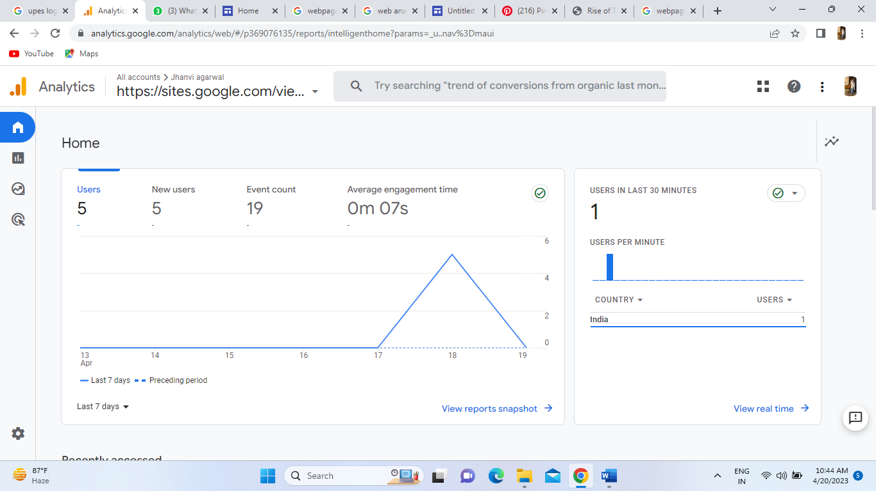

About The Report Section –

The Reports section in Google Analytics provides a wide range of data and insights related to website traffic and user behavior. This section offers a variety of pre-built reports that can be customized to meet the needs of website owners. Here are some of the key features of the Reports section:

1. Audience Reports: This section provides demographic and interest data about your website visitors, including age, gender, interests, and location.

2. Acquisition Reports: This section shows how users are getting to your website, including which channels are driving the most traffic, such as organic search, paid search, social media, and referrals.

3. Behavior Reports: This section tracks user behavior on your website, such as the pages they visit, how long they stay on each page, and how often they return to your site.

4. Conversion Reports: This section tracks the actions users take on your website that you consider to be valuable, such as completing a purchase or filling out a contact form.

5. Real-Time Reports: This section provides real-time data on user behavior on your website, including how many people are currently on your site, which pages they are viewing, and which sources are driving the most traffic.

6. Custom Reports: This feature allows you to create your own customized reports based on specific metrics and dimensions that are important to your business.

7. Goals: This feature allows you to track specific actions that you want users to take on your website, such as filling out a form or completing a purchase.

8. E-commerce Tracking: This feature tracks user behavior related to online purchases, such as product views, add to cart actions, and completed transactions.

Overall, the Reports section in Google Analytics provides a wealth of data and insights that can be used to optimize your website for better user engagement, higher conversion rates, and increased revenue. By regularly monitoring and analyzing this data, website owners can make informed decisions about how to improve their website and better meet the needs of their audience.

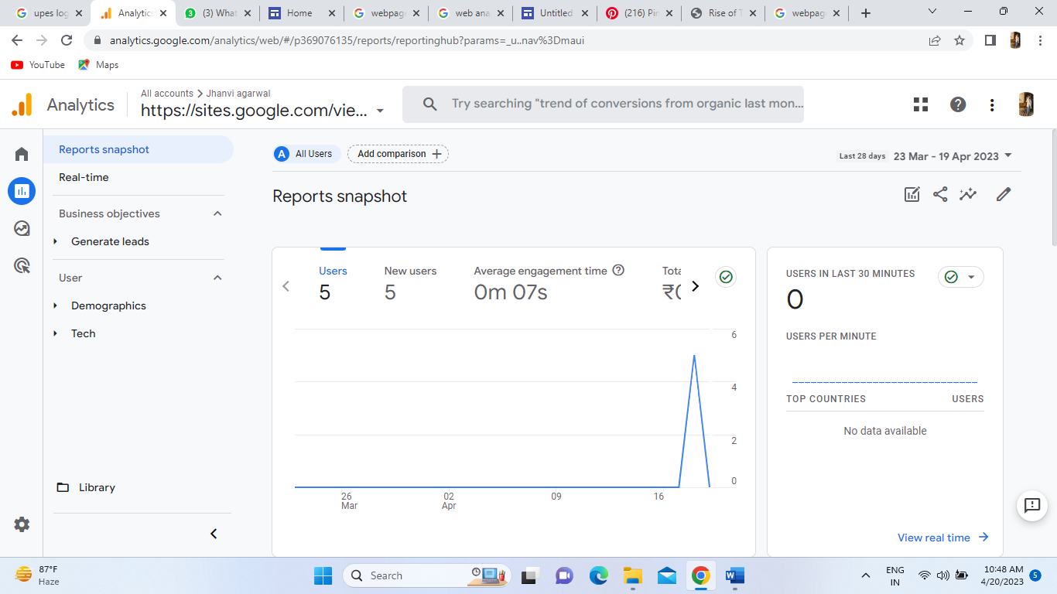

About the Advertising Section -

The Advertising section in Google Analytics provides insights into the performance of your advertising campaigns and helps you optimize your ad spend for better ROI. Here are some of the key features of the Advertising section:

1. Campaigns: This feature allows you to track the performance of your advertising campaigns, including paid search, display ads, and social media ads. You can set up UTM parameters for your campaigns and track the resulting traffic and conversions in Google Analytics.

2. AdWords: If you are running ads through Google AdWords, you can link your AdWords account to your Google Analytics account to get more detailed insights into your ad performance. This will allow you to track the effectiveness of your ads and optimize your campaigns for better ROI.

3. Remarketing: Remarketing is a feature that allows you to show ads to users who have previously visited your website. By enabling remarketing in Google Analytics, you can create custom audiences based on user behavior and target them with relevant ads.

4. Display Advertising: If you are running display ads on the Google Display Network, you can track the performance of your ads in Google Analytics. This will allow you to see which placements and targeting options are driving the most traffic and conversions.

5. Multi-Channel Funnels: This feature allows you to see how different marketing channels are contributing to your conversions. You can see which channels users interacted with before converting, giving you a more complete picture of the customer journey.

